**Business problem**

Create a model that tells what are the variables that influenced a person to buy a car or not after being exposed to an add on a social network.

**Explaining the model**

1. Import the dataset, which is in a csv format.
2. We need to get rid of the columns that we won’t look at (gender and ID), so we need to subset the dataset.
3. For this specific model, we need to set our dependent variable as a factor, to be able to use the predictor in the matrix later.
4. After that, we will split the dataset into a training and test set (a 75% do the training set will be enough, as our dataset has 400 entries in total).
5. Before creating the classifier, we need to put all values on the same scale (after the sub-setting, the columns have new indexes).
6. For the classifier, the first argument are the independent variables, the second argument is the dependent variable and the third argument is the number of trees.

**Plotting the results**

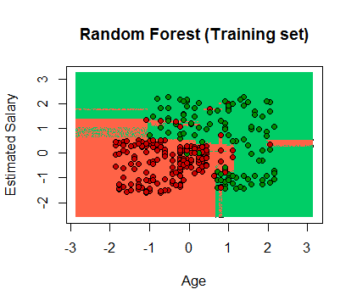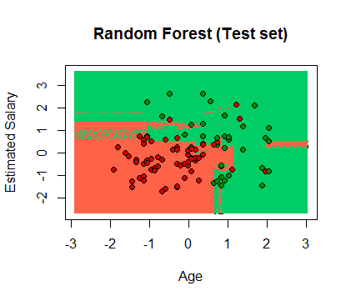

**Evaluating the model’s performance**

The confusing matrix allows us to compare the right vs wrong predictions.



As we can see, we got a total of 83 correct predictions (83%) and 17 wrong predictions (17%), from which 9 are false positives (type I) and 8 are false negatives (type II).